**Cloudera setup in Virtual Box for Mac**

**Group Activity 01**

In this activity, you are going to setup a virtual environment for running Hadoop MapReduce code , run simple commands , create a file , search through the file .

**Setup Hadoop Virtual Environment**

To setup a single node cluster, on your laptop , you need following software:

1. Oracle Virtual Box – software to install one or more virtual machines. Get this software from <https://www.virtualbox.org/>
2. Cloudera VM – this software acts as a virtual machine. By default, Cloudera consist of packages of most of the cloud computing frameworks like Hadoop, Spark, Hive, Pig, etc. Download Cloudera QuickStart VM for Virtual Box platform. Go get this software, go to <http://www.cloudera.com/> 🡺 Select **Get Started** 🡺 Select **Try Now** 🡺 Select **Download Now** inside **QuickStarts** box 🡺 Select a platform as **Virtual Box**. Fill a form that pops up after this step and download Cloudera.

Please follow the below steps to import the cloudera vmdk file to your local machine through Virtual Box or you can follow a video from the following link to install Cloudera and Virtual Box:

<https://www.youtube.com/watch?v=BeCtjd86YXo>

**Step1:** Open the Oracle Virtual Box:

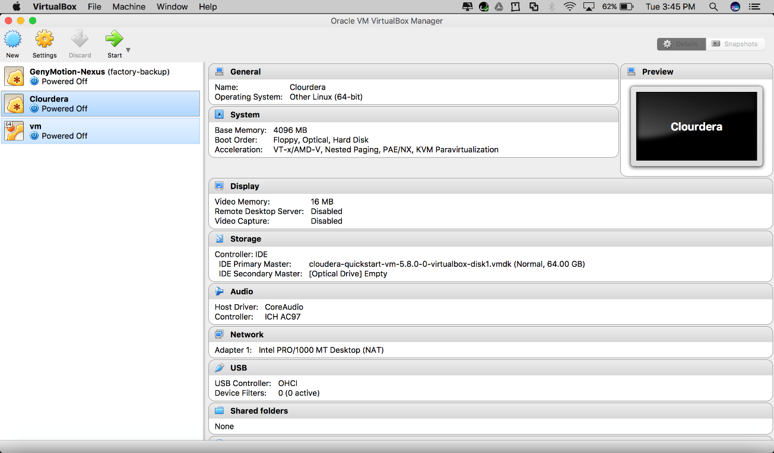

**Step2**: Click New in the top left corner

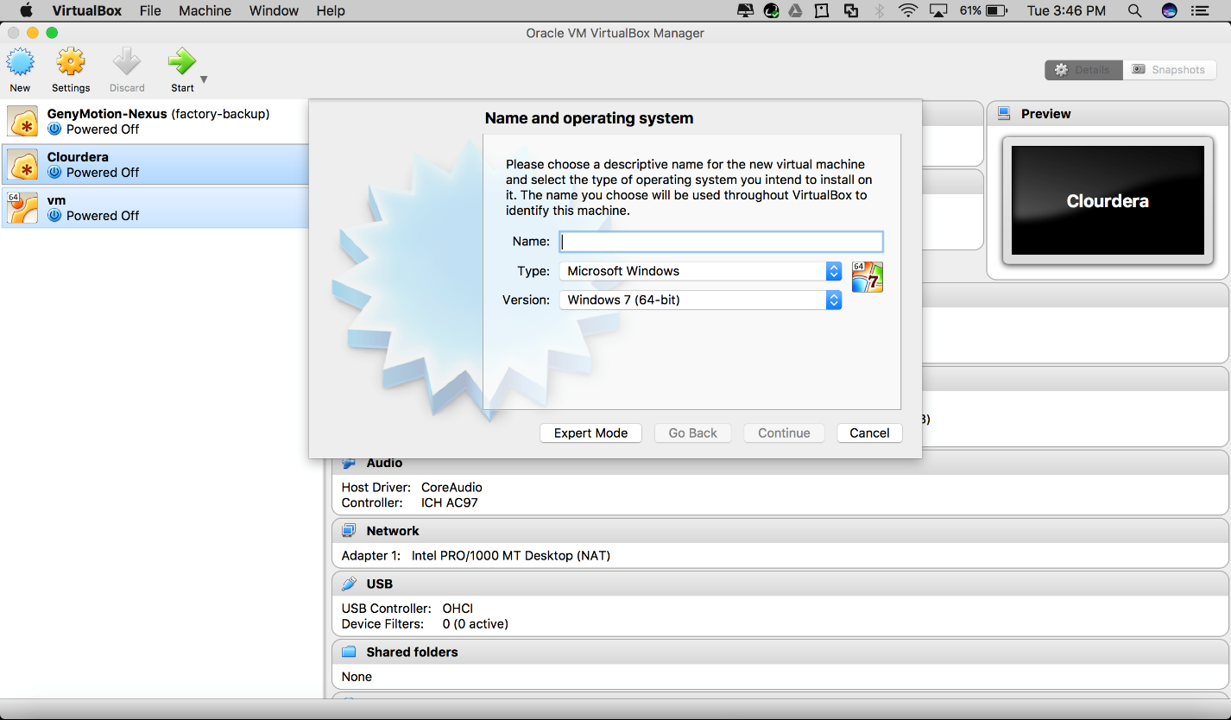

**Step3:** Give a name for your cloudea virtual machine and select type as ‘Linux’ and version as ‘Other Linux (64-bit) and click continue

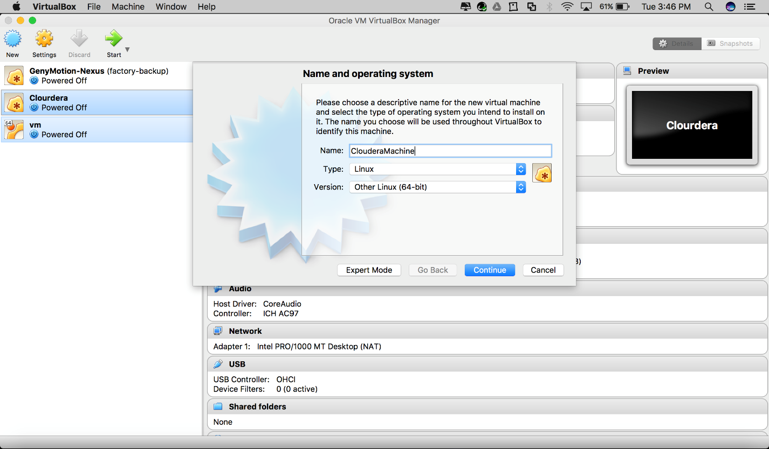

**Step4:** Keyin the memory as 4096 MB and click continue

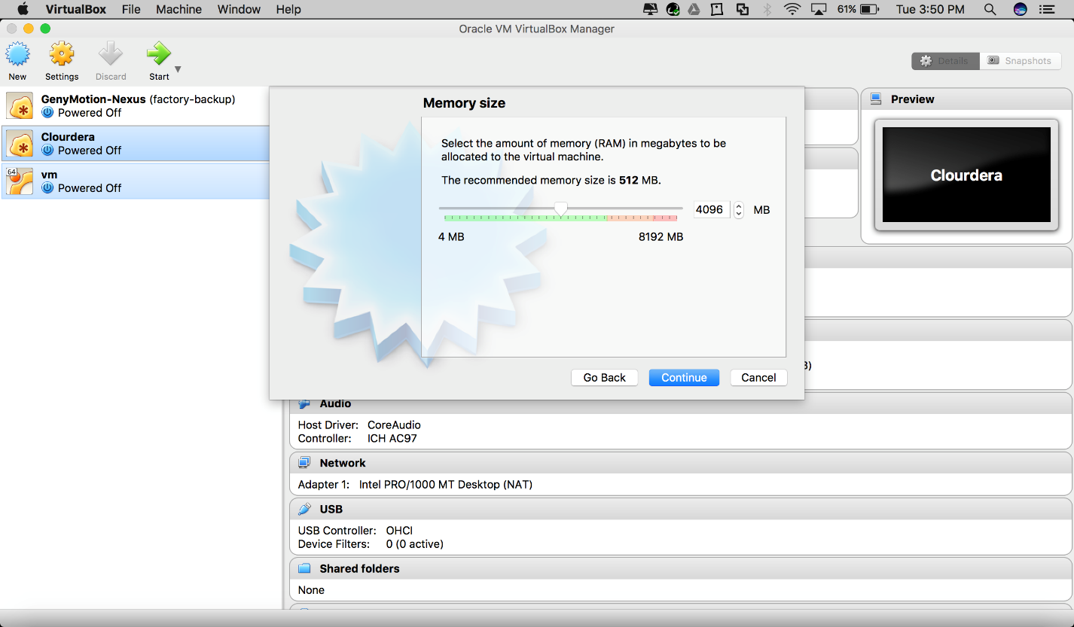

Step5: Select the option use an existing virtual hard disk file and click the browse link and then Browse and select the downloaded vmdk file, click open and click on create.

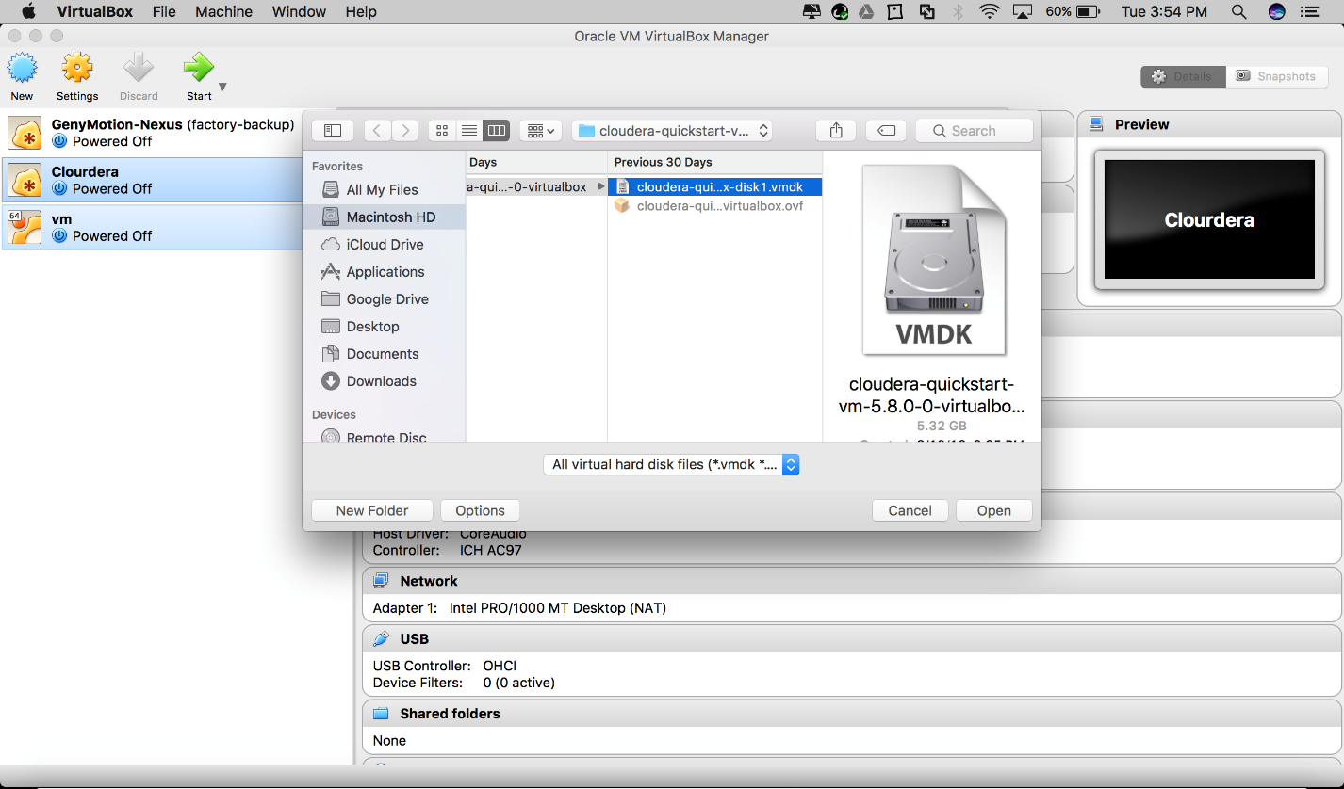

**Step6:** Ensure the settings are similar to the below screenshot

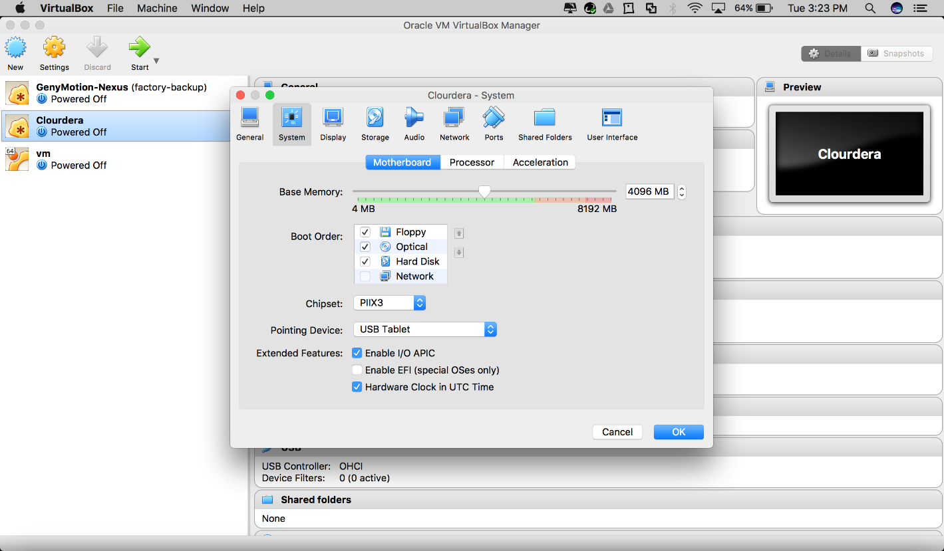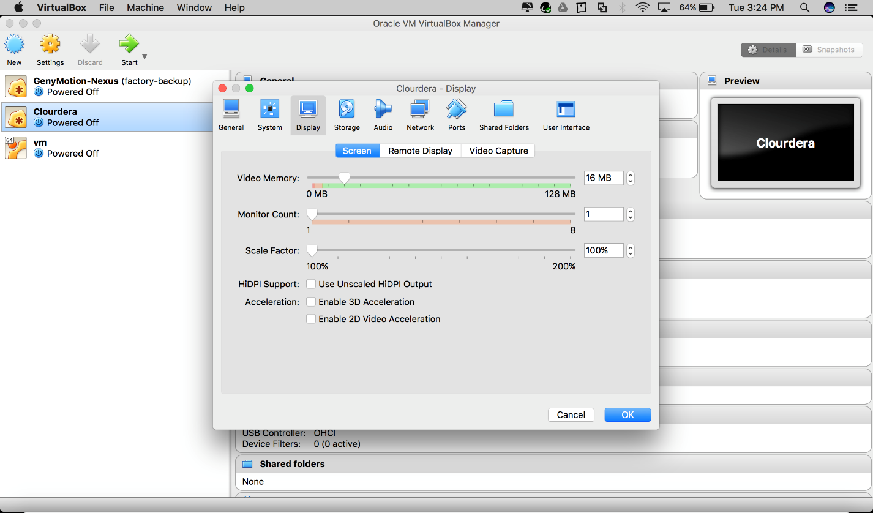

Select the installed Virtual Machine and click Start. Wait for all configurations to setup.